RENT A CAR BY
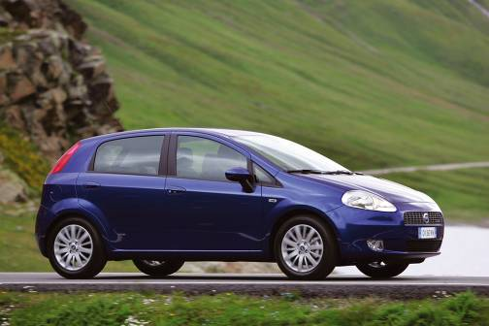

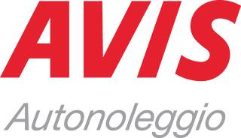

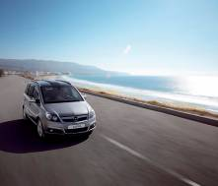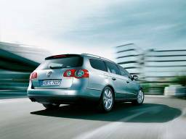

ITALY NET PRICES VALID FROM 1.04.2009 TILL 31.3. 2010
Grp | Modelo | carbur. | a/c | min 2d.  por dia |  | Min 14 d.  por dia | min 21 d.  por dia
A | Matiz 1.0  Fiat Panda 1.2 | petrola |  | € 34,00 |  | € 32,50 | € 30,60
B | Fiat Punto1,2  Opel Corsa 1,2 | petrol | SI | € 35,00 |  | € 33,50 | € 32,00
C | TDI Fiat Punto1,3 | diesel | SI | € 38,50 |  | € 36,70 | € 34,60
J | Nissan Micra Matic  Lancia Y | Mixed | SI | € 44,00 |  | € 41,80 | € 39,50
D | Opel Astra 1,7 cdti  Ford Focus 1,6 | Mixed | SI | € 39,00 |  | € 37,10 | € 34,50
E | Ford Focus SW  Opel SW | Diesel | SI | € 43,00 |  | € 40,90 | € 37,90
F | Fiat Croma  Ford Focus C Max | Diesel | SI | € 44,40 |  | € 42,30 | € 40,00
I | Wolkswagen Golf plus | Mixed | SI | € 49,80 |  | € 47,40 | € 45,00
G | Opel Zafira  Ford S Max  Renault Scenic | Diesel | SI | € 54,80 |  | € 52,20 | € 49,40
P | Nissan X-trail  Chevrolet Captiva | Diesel | SI | €60,20 |  | € 57,40 | € 54,40
H | Alfa 159  BMW Serie 3 | Diesel | SI | € 76,50 |  | € 72,80 | € 69,30
L | Mercedes Classe E  Crysler 300 CRDI | Diesel | SI | € 83,00 |  | € 79,00 | € 75,20
K | Ford Galaxy  Fiat Ulysse | Diesel | SI | € 115,70 |  | € 110,00 | € 105,00
M | Fiat Ducato  Ford Transit | Diesel | SI | € 138,60 |  | € 131,80 | € 126,00
* Not available in all the office AC – aire acondicionado, CL – climatizado; A - automatic
booking:
° it’s necesary Avis voucher
° the reservation and voucher have to indicate the rate and code
rate includes:  ° unlimited mileage  ° CDW- TP  ° 15% apt surchange  ° 8% railway surcharge  ° tax 20%  ° domestic one way |  |  |  |  | rate excludes:  ° refuelling charges  ° delivery and collection  ° nwe cdw and tp standard excess valid at the time of rental check out  °days not used are not refundable  °additional driver  ° Road Tax ° Pai  ° administration fee

RENT A CAR AVIS 2010/2011

ITALY NET PRICES VALID FROM 01.04. 2010 TILL 31.3. 2011
Grp | Model | carbur. | a/c | min 2d.  per day | Min 14 d.  per day
A | Fiat Panda 1.2 | petrol |  | € 32,50 | € 30,00
B | Fiat Punto1,2  Opel Corsa 1,2 | petrol | okI | € 33,50 | € 30,50
C | Volkswagen Polo TDI, Fiat Grande Punto1,3 | diesel | ok | € 35,50 | € 32,50
J | Nissan Micra Matic  Lancia Y | Mixed | ok | € 41,00 | € 37,00
D | Opel Astra 1,7 cdti  Ford Focus 1,6 | Mixed | ok | € 37,50 | € 36,50
E | Ford Focus SW  Opel SW | Diesel | ok | € 42,50 | € 39,00
F | Fiat Croma  Alfa 159 | Diesel | okI | € 45,00 | € 40,50
I | Wolkswagen Golf plus | Mixed | ok | € 44,50 | € 40,50
G | Opel Zafira  Ford S Max  Renault Scenic | Diesel | ok | € 52,50 | € 47,50
P | Nissan X-trail  Chevrolet Captiva | Diesel | ok | € 56,00 | € 51,00
H | Mercedes C  BMW Serie 3 | Diesel | ok | € 82,50 | € 75,00
L | Mercedes Classe E  BMW Serie 5 | Diesel | ok | € 107,50 | € 97,50
K | Ford Galaxy  Fiat Ulysse | Diesel | ok | € 110,00 | € 99,00
M | Fiat Ducato  Ford Transit | Diesel | ok | € 129,00 | € 117,00
* Not available in all the office AC – air conditioning, CL – climatizado; A - automatic

booking:
° it’s necesary Avis voucher
° the reservation and voucher have to indicate the rate and code
rate includes:  ° unlimited mileage  ° CDW- TP  ° 15% apt surchange  ° 8% railway surcharge  ° tax 20%  ° domestic one way | rate excludes:  ° refuelling charges  ° delivery and collection  ° nwe cdw and tp standard excess valid at the time of rental check out  °days not used are not refundable  °additional driver  ° Road Tax ° Pai  ° administration fee

